 |  |  | Data Element Request Form (DERF)/  External Code List (ECL)  National Council for Prescription  Drug Programs |  |  |  |  |  |  | DERF #: 1068  ECL #:  RECEIPT DATE: 05/02/12  WG MTG REVIEW DATE(S): 08/08/12-08/10/12 |  |  |  |  |  | FINAL DERF RESOLUTION  DERF ECL Emergency ECL  Approved – No Modifications  Approved – With Modifications  Denied  Pended 1 2 3 (No further action)  Withdrawn
Please refer to instructions below before completing
 |  | References other SDO Data Dictionary (list SDO, standard and version):
Describe the business need or purpose addressed by this DERF/ECL submission (required):
IN AN EFFORT TO MAKE DUE INFORMATION PASSED BETWEEN TRADING PARTNERS MORE USABLE:
1. IN DRU 100-4&5 CO-AGENT SEGMENT, WHICH ALREADY CONTAINS THE DRU 100-4 COAGENT ID AND DRU 100-5 COAGENT QUALIFIER, ADD A DRUG DESCRIPTION ELEMENT (105 CHARACTER??) TO EXISTING DRU 100. THIS WILL ALLOW THE DRUG IN QUESTION TO BE MORE EASILY IDENTIFIED SO A CODE SEARCH IS NOT NEEDED WHEN REVIEWING DUE INFORMATION.

2. IN DRU 100-4&5 CO-AGENT SEGMENT, WHICH ALREADY CONTAINS THE DRU100-4 COAGENT ID AND DRU 100-5 COAGENT QUALIFIER, ADD A DIAGNOSIS CODE, DIAGNOSIS CODE QUALIFIER, AND DIAGNOSIS CODE DESCRIPTION ELEMENTS. THIS WILL ALLOW THE CONFLICTING DISEASE STATE TO BE EASILY IDENTIFIED BY THE RECEIVER OF THE INFORMATION IN THE CASE OF A DRUG DISEASE DRUG UTILIZATION EVALUATION NOTICE.

New data element (DERF only)
Proposed Name (required):
Size (required): |  |  |  |  |  |  | Format (required):
Segment for the New Data Element (required for Telecom, XML Standard):
Definition (required):
Codes/Values – every code/value must include a definition (Use attachments if necessary): (Maintenance and Control will determine actual code or value)
Value Suggested | Value Definition (required) | Value Explanation (required)

Reject Codes/Values – standard reject codes will be assigned by Staff. List any new reject code (s) and include a definition (Use attachments if necessary): (Maintenance and Control will determine actual value)
Value Suggested | Value Definition (required) | Value Explanation (required) | Standard(s) - Which standard(s)  is the Reject Code used in?

Proposed XML Tag (required if data element is in an XML standard):

Number of Repetitions for New Data Element (required if repeating data element):

Fill out Transaction Usage section next.
Change existing data element (All information is required for changes)
Field Number (Telecom): |  |  |  |  | ID: |  |  |  |  | Name:
XML Tag (XML Standard based)) |  |  |  |  | Name:
Requested change to (choose at least one): |  |  |  | Size |  | Format |  |  |  | Values |  |  |  |  | Definition |  | Name
Summarize Proposed Changes (Use attachments if necessary):
Codes/Values – every code/value change must include a definition (Use attachments if necessary):
Value Suggested | Value Definition (required) | Value Explanation (required)

Data Element Transaction Usage
Fill out Transaction Usage section next
Transaction Usage - Which transaction(s) is the field used in? (check all that applies) (Use attachments if necessary): (required for Telecom or Batch Standard)
Telecom or Batch Transactions | Used in transaction (Y/N)? | If Used = Yes (Y), Situation must be provided.
Eligibility Verification
Claim Billing/Rebill/Encounter
Service Billing/Rebill
Predetermination of Benefits
Claim Reversal
Service Reversal
Prior Authorization Request and Billing (Claim)
Prior Authorization Request and Billing (Service)
Prior Authorization Reversal (Claim)
Prior Authorization Reversal (Service)
Prior Authorization Inquiry
Prior Authorization | Request Only (Claim)
Prior Authorization Request Only (Service)
Information Reporting/Rebill (Claim)
Information Reporting/Rebill (S | rvice)
Information Reporting Reversal (Claim)
Information Reporting Reversal (Service)
Controlled Substance Reporting/Rebill (specify non-prescription or general)
Controlled Substance Reporting Reversal (specify non-prescription or general)

Transaction Usage - Which transaction(s) is the field used in (check all that apply)? (Use attachments if necessary): (required for XMLStandard)
Transport Transactions | Used in transaction (Y/N)? | If Used = Yes (Y), Situation must be provided.
Error
Status
Verify
Get Message
Password Change
SCRIPT Transactions | Used in transaction (Y/N)? | If Used = Yes (Y), Situation m
New Prescription Requestst be provided.

Refill Request/Response or Resupply
Prescription Change Request/Response
Prescription Fill | Status Notification
Cancel Prescription Request/Response
Medication History Request/Response
Drug Administration
Specialized Transactions | Used in transaction (Y/N)? | If Used = Yes (Y), Situation must be provided.
Census
MTM

Transaction Usage – For standards other than Telecom, Batch, or XML, please include attachments as needed.
Describe how the new/revised data element will be used:
Describe anticipated impacts/implementation considerations:
Submitter (This Section Must Be Completed)
Name: Jason Reed |  |  |  |  |  |  |  |  | Work Group submitting DERF: Task Group submitting DERF:
Title: Sr. Manager ePrescribing Business |  |  |  |  |  |  |  |  |  |  |  |  |  | Fax:
Company: Express Scripts, Inc. |  |  |  |  |  |  |  |  |  |  |  |  |  | email: Jason_reed@medco.com
Address: 10186 Germantown Middletown Road
City/State/Zip: Germantown, Ohio 45327 |  |  |  |  |  |  |  |  |  |  |  |  | Phone: 513-594-5003
Signature: submitted electronically |  |  |  |  |  |  |  |  |  |  |  |  | Date: 05/02/12
TELECOMMUNICATION STANDARD ONLY  REQUESTING EMERGENCY ECL CHANGE associated to Regulatory/Legislative Compliance  If approved, the request will appear in the next ECL publication. There will be a minimum of 180 days required before the implementation of an emergency ECL change. Please see the attached Publication Release/ Implementation Dates Chart. |  |  |  |  |  |  |  |  |  |  |  | Reason for Emergency Change / Reference to Regulation or Legislation  Date Needed By:  (no earlier than 180 days from the ECL Publication)
DERF/ECL Instructions
Please refer to the following instructions when completing this DERF/ECL form. Use additional attachments when necessary to provide complete information. Incomplete forms will be returned for additional information prior to processing. This form is used for multiple purposes. 1) To add/modify a data element to the Data Dictionary. 2) To add/modify a data element code to the External Code List (ECL). 3) To add/modify information in a standard or implementation guide.
Describe the business need or purpose addressed by this DERF/ECL
This section should explain, in detail, what the requester would like changed, added, or deleted and the technical and/or reasons why the modifications are necessary. The written explanation should give the readers an understanding as to what the requester is attempting to accomplish.
Describe Information Needed For Adds/Changes
(DERF only:) Use the New data element section to indicate the proposed field name, the size (length, including decimals, if applicable), and the format (numeric, alpha/numeric, dollar). For a New data element to the Telecommunications Standard, include the proposed Segment the element would be added to. Include a definition of the field. If applicable, every value/code requested must contain a definition. For the Telecommunication or Batch Standard, specify the situation in which this new field would be used. (DERF or ECL:)To change a data element, complete the Change existing data element section, indicating the current data dictionary information. Check what information is changing: field size (length), format (numeric, alpha/numeric, dollar), adding or changing a value, field name or definition. Summarize all changes that are being requested. EMERGENCY ECL REQUESTS via a DERF form PERTAIN ONLY TO THE TELECOMMUNICATION STANDARD. Used for regulatory and legislative changes which require the addition of a value(s) to be implemented prior to the scheduled annual implementation date of the next ECL Publication. There will be a minimum of 180 days post ECL publication required, before the implementation of an emergency ECL change.
Describe How The Data Element Will Be Used
This section needs a detailed description of how and where the data element or value change will be used in the processes governed by the specified standards. For example: If the data element is referenced in multiple standards, is the usage consistent? Will this data element or value change cause a drug claim to reject? How will the data element impact an individual’s enrollment status? If the data element has a specified list of values, who will be responsible for maintaining the list?
Describe The Impacts And Implementation Consideration Involved In Requesting That This Information Be Included In NCPDP Standards
This section is intended to obtain information about the level of consideration given to the operational impacts of including this data element addition/change in the affected standard(s). Is this the most appropriate source for the data element? Are there legislative and/or legal time frames/requirements? Are there specific implementation considerations that should be documented in an implementation guide?
For MC Maintenance and Control Use Only
Work Groups that may be impacted (check all appropriate boxes):
 | WG1 Telecommunication |  |  |  |  |  |  |  |  |  | WG11 ePrescribing & Related Transactions
 | WG2 Product Identification |  |  |  |  |  |  |  |  |  | WG14 Long Term Care
 | WG3 Standard Identifiers |  |  |  |  |  |  |  |  |  | WG16 Property and Casualty/Workers’ Compensation
 | WG7 Manufacturer Rebates |  |  |  |  |  |  |  |  |  | WG17 Pharmaceutical Pedigree and Traceability
 | WG9 Government Programs |  |  |  |  |  |  |  |  |  | WG45 External Standards Assessment, Harmonization, and Implementation Guidance
 | WG10 Professional Pharmacy Services |  |  |  |  |  |  |  |  |  | MC Maintenance and Control
 | Other
Return completed form by email, mail or fax:
NCPDP, 9240 E. Raintree Drive, Scottsdale, Arizona 85260-7519
email DERF@NCPDP.org  fax (480) 767-1042  phone (480) 477-1000

This section is used by NCPDP Staff Only
DERF MODIFICATIONS (Actions Taken by WG(s) Review)
WG11
DERF/ ECL STATUS:
Approved/Reviewed with no modifications
Approved/Reviewed with modifications (complete modifications below)
Pended by work group
Reason:
Denied by Work Group
Withdrawn by submitter

Changed ECL to DERF (also check appropriate DERF status)
Reason:

Vote | Pink | Yellow | Green | Total
Approved
Opposed

Modifications: Modifications are the “After MC Modeling Task Group Discussion” and the pages that follow.

MC
DERF/ ECL STATUS:
Approved/Reviewed with no further modifications
Approved/Reviewed with further modifications (complete modifications below)

Vote | Pink | Yellow | Green | Total
Approved
Opposed

Modifications:
The addition of the Diagnosis under DUE is redundant because CoAgent supports SNOMED and ICD. Remove this.

The CoAgent is to be a triplicate – Code, Qualifier, and Description. (Desc is new). All mandatory.
We do not add the Diagnosis underneath the CoAgent. This is because the CoAgent Qualifier is a list of values, and of those values, a diagnosis is allowed to be sent. So adding the Diagnosis is redundant.

Diagnosis in Medication (Primary and Secondary) should both have a Description added. All mandatory.

Current:
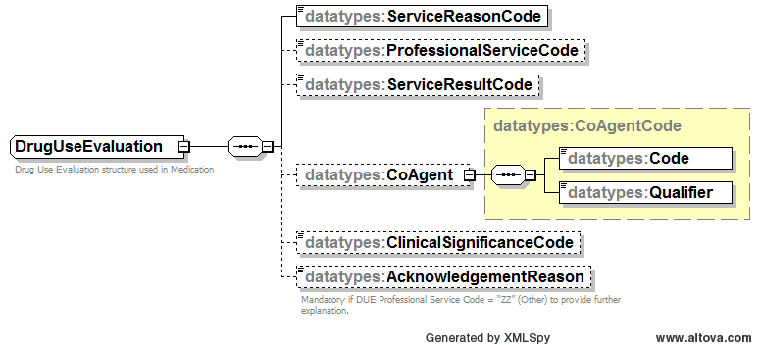

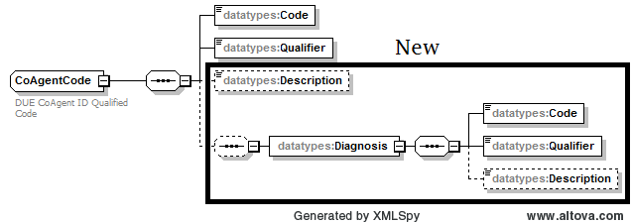

AFTER MC Modeling Task Group Discussion:

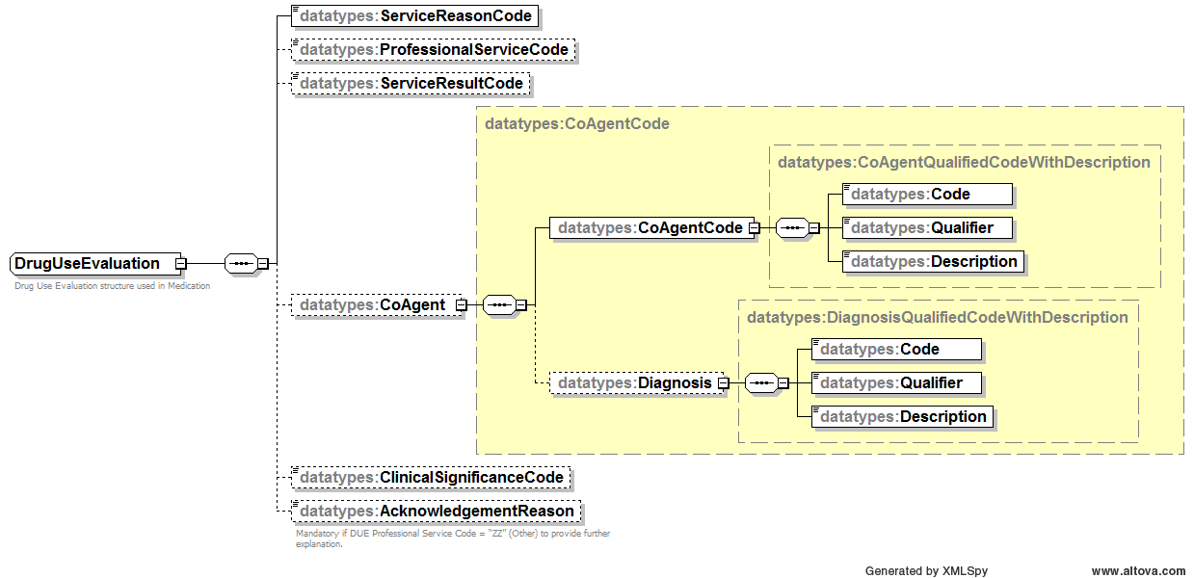

- Consideration of Text (CoAgent and Diagnosis) as mandatory or optional. Backwards compatability is not a problem. The Sig rules say Text, Code, Qualifier are mandatory. Do we use the same rule? Yes – Text, Code, Qualifier mandatory.
  - After MC Modeling TG review, for consistency, use the same for Medication Diagnosis and CoAgent Diagnosis Text/Code/Qualifier.
- CoAgentCode - Add Text and the Code, Qualifier, and Text become a triplicate as the standard now supports (see Sig elements added last ballot).
  - Text must match what is in Code look up (standard rule established in Sig and going forward) – add to xsd.
- Diagnosis in CoAgent – Add Text and the Code, Qualifier, and Text become a triplicate as the standard now supports (see Sig elements added last ballot).
  - Text must match what is in Code look up (standard rule established in Sig and going forward) – add to xsd.
  - Must use the same enumerations as Diagnosis in Medication.
  - Add to Imp Guide - THIS WILL ALLOW THE CONFLICTING DISEASE STATE TO BE EASILY IDENTIFIED BY THE RECEIVER OF THE INFORMATION IN THE CASE OF A DRUG DISEASE DRUG UTILIZATION EVALUATION NOTICE.
- This affects Diagnosis defined in Medication as well. Make triplicate to be consistent.
  - Text must match what is in Code look up (standard rule established in Sig and going forward) – add to xsd.
  - See current diagram below.
  - The enumerations are the same as the CoAgent Diagnosis.
- Does not affect Diagnosis in Census transaction as it is a different structure for reporting.
- Implementation Guide modifications (see next section).

Current Diagnosis (not Census)

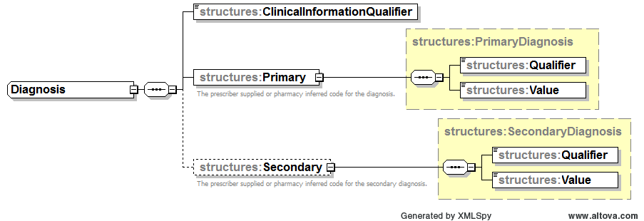

MC Modeling Task Group Recommendation:

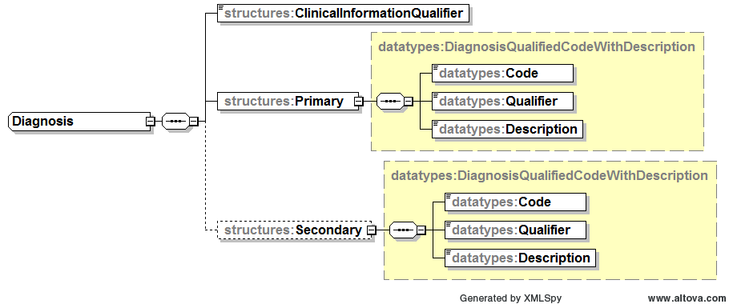

8.1.4.2 DrugUseEvaluation Element
The elements <ServiceReasonCode>, <ProfessionalServiceCode>, and <ServiceResultCode> reference data elements from the NCPDP Data Dictionary. For example, <ServiceReasonCode> uses the possible values from the NCPDP Data Dictionary element Reason For Service Code. Not all values listed in the fields in the NCPDP Data Dictionary may be appropriate for all business case scenarios. Consult trading partners for more information on the appropriate values supported.

Drug-to-Allergy Interaction Example
In this example, a potential drug-to-allergy conflict is identified during the prescribing process, based on the patient’s screened allergy codes. The prescriber’s system deems the severity of the conflict to be major.

Because the patient has tolerated the medication in the past, the prescriber is proceeding with the prescription, and has provided a coded acknowledgment reason in the <ProfessionalServiceCode> as well as further textual information in the <AcknowledgmentReason>.
Element | Value | Note
<ServiceReasonCode> | DA | Type of conflict identified: Drug-to-Allergy
<ProfessionalServiceCode> | PA | Previous patient tolerance - Patient has taken medication previously without issue
<ServiceResultCode> | 4A | Prescribed with Acknowledgements
<CoAgentID> | [NDC11]  Or  [RxNorm Code] | Representative NDC or RxNorm Code for related drug
<CoAgentIDQualifier> | ND | NDC qualifier or appropriate RxNorm Code qualifier
<CoAgentText> | Xxxxx | Textual description of Code from Source.
<ClinicalSignificanceCode> | 1 | Major
<AcknowledgementReason> | “Tolerated course of medication in October 2007” | Prescriber’s additional free text explanation.

Drug-to-Condition Interaction Example
In this example, a potential drug-to-condition conflict is identified during the prescribing process, based on the patient’s current diagnoses. The prescriber’s system deems the severity of the conflict to be minor.

The prescriber is proceeding with the prescription, and has provided an appropriate value in the DUE <AcknowledgmentReason> element.
Element | Value | Note
<ServiceReasonCode> | MC | Type of conflict identified: Drug-Disease (Reported)
<ProfessionalServiceCode> | MP | Prescriber is aware of the risk and will be monitoring the patient
<ServiceResultCode> | 4A | Prescribed with Acknowledgements
<CoAgentID> | [ICD9 code]  Or  [ICD10 code] | ICD9 or ICD10 code representing the conflicting diagnosis
<CoAgentIDQualifier> | DX | ICD9 qualifier or appropriate ICD10 qualifier
<CoAgentText> | Xxxxx | Textual description of Code from Source.
<ClinicalSignificanceCode> | 3 | Minor
<AcknowledgementReason> |  | Blank. Element is not required unless the value in the <ProfessionalServiceCode> is ZZ – Other Acknowledgment

Drug-to-Drug Interaction Example
In this example, a potential drug-to-drug conflict is identified during the prescribing process, based on the patient’s current medication profile. The prescriber’s system deems the severity of the conflict to be moderate.

The prescriber is proceeding with the prescription, and has provided an appropriate value in the DUE <AcknowledgmentReason> element.
Element |  | Value | Note
<ServiceReasonCode> |  | DD | Type of conflict identified: Drug-Drug Interaction
<ProfessionalServiceCode> |  | MP | Prescriber is aware of the risk and will be monitoring the patient.
<ServiceResultCode> |  | 4A | Prescribed with Acknowledgements
<CoAgentID> |  | [NDC11]  Or  [RxNorm Code] | Representative NDC or RxNorm Code for related drug
<CoAgentIDQualifier> |  | ND | NDC qualifier or appropriate RxNorm Code qualifier
<CoAgentText> | Xxxxx |  | Textual description of Code from Source.
<ClinicalSignificanceCode> |  | 2 | Moderate
<AcknowledgementReason> |  |  | Blank. Element is not required unless the value in the <ProfessionalServiceCode> is ZZ – Other Acknowledgment

Duplicate Drugs Example
In this example, a drug duplication is identified during the prescribing process, reflecting that multiple prescriptions of the same drug formulation are present in the patient’s current medication profile. The prescriber’s system deems the severity of the conflict to be major.

The prescriber is proceeding with the prescription, and has provided a textual acknowledgment reason in the <AcknowledgmentReason> element, using the ZZ – Other Acknowledgment value in the <ProfessionalServiceCode>
Element |  | Value | Note
<ServiceReasonCode> |  | UD | Duplicate Drug
<ProfessionalServiceCode> |  | ZZ | Other Acknowledgment
<ServiceResultCode> |  | 4A | Prescribed with Acknowledgements
<CoAgentID> |  | [NDC11]  Or  [RxNorm Code] | Representative NDC or RxNorm Code for related drug
<CoAgentIDQualifier> |  | ND | NDC qualifier or appropriate RxNorm Code qualifier
<CoAgentText> | Xxxxx |  | Textual description of Code from Source.
<ClinicalSignificanceCode> |  | 4 | Major
<AcknowledgementReason> |  | “This medication…” | Prescriber’s free text. Element is required when the value in the <ProfessionalServiceCode> is ZZ – Other Acknowledgment

Duplicate Ingredients Example
In this example, a duplicate ingredient conflict is identified during the prescribing process, reflecting multiple prescriptions with the same active ingredient are present in the patient’s current medication profile.
Element |  | Value | Note
<ServiceReasonCode> |  | ID | Ingredient Duplication
<ProfessionalServiceCode> |  | ZZ | Other Acknowledgment
<ServiceResultCode> |  | 4A | Prescribed with Acknowledgements
<CoAgentID> |  | [NDC11]  Or  [RxNorm Code] | Representative NDC or RxNorm Code for related drug
<CoAgentIDQualifier> |  | ND | NDC qualifier or appropriate RxNorm Code qualifier
<CoAgentText> | Xxxxx |  | Textual description of Code from Source.
<ClinicalSignificanceCode> |  | 4 | Major
<AcknowledgementReason> |  | “This medication…” | Prescriber’s free text. Element is required when the value in the <ProfessionalServiceCode> is ZZ – Other Acknowledgment

Duplicate Therapy Example
In this example, a duplicate therapy conflict is identified during the prescribing process, reflecting that multiple prescriptions of the same therapeutic class are present in the patient’s current medication profile.
Element |  | Value | Note
<ServiceReasonCode> |  | TD | Duplicate Therapy
<ProfessionalServiceCode> |  | ZZ | Other Acknowledgment
<ServiceResultCode> |  | 4A | Prescribed with Acknowledgements
<CoAgentID> |  | [NDC11]  Or  [RxNorm Code] | Representative NDC or RxNorm Code for related drug
<CoAgentIDQualifier> |  | ND | NDC qualifier or appropriate RxNorm Code qualifier
<CoAgentText> | Xxxxx |  | Textual description of Code from Source.
<ClinicalSignificanceCode> |  | 4 | Major
<AcknowledgementReason> |  | “This medication…” | Prescriber’s free text. Element is required when the value in the <ProfessionalServiceCode> is ZZ – Other Acknowledgment

Geriatric Precaution Example
In this example, a geriatric precaution is noted during the prescribing process, indicating that the prescribed medication should be used with caution for a geriatric patient. The associated <ServiceReasonCode> value is “PA, Drug–Age.”
Element |  | Value | Note
<ServiceReasonCode> |  | PA | Drug - Age
<ProfessionalServiceCode> |  | MP | Prescriber is aware of the risk and will be monitoring the patient.
<ServiceResultCode> |  | 4A | Prescribed with Acknowledgements
<CoAgentID> |  |  | (not sent)
<CoAgentIDQualifier> |  |  | (not sent)
<CoAgentText> | Xxxxx |  | Textual description of Code from Source.
<ClinicalSignificanceCode> |  | 3 | Moderate
<AcknowledgementReason> |  |  | Not sent. Element is not required unless the value in the <ProfessionalServiceCode> is ZZ – Other Acknowledgment

Lynne’s email (8/16/12)

New ballot of August DERFs

- Coming out of August WG, DERF 001068 was approved with mods.
The CoAgent is to be a triplicate – Code, Qualifier, and Description. (Desc is new). All mandatory.
We do not add the Diagnosis underneath the CoAgent. This is because the CoAgent Qualifier is a list of values, and of those values, a diagnosis is allowed to be sent. So adding the Diagnosis is redundant.

Diagnosis in Medication (Primary and Secondary) should both have a Description added. All mandatory.

- DERF 001069 was pended, so no changes to the schema for the ZIP/Postal stuff.
- DERF 001072/ECL 119 was approved; I just have to change the examples that have a Diagnosis in them. I don’t think any changes to the Model. But please verify.
- See next email on the Quantity.

Compound Quantity inconsistency

DERF 001074 Compound Quantity - Modify size from 9(7)v999 (1Ø digits) to 9(7)v9999999 (14 digits).
I just noticed that SCRIPT Quantity (used in non-compound quantity and compound ingredient quantity areas) is numeric 11.
They were inconsistent because they came from different standards (NCPDP and X12).
Both SCRIPT and Telecom are going to ballot with DERFs. Do I increase the Quantity in SCRIPT to numeric 14? (I think yes)

Z and W are UCFs, so no affect really. A is Post Adjudication. That is affected also. This would cause a Post Adjudication ballot also. (I think yes)

448-ED | Compound Ingredient Quantity | Amount expressed in metric decimal units of the product included in the compound mixture. | 9(7)v999 | T,A,Z,W

So for the August ballot, the Quantity field used in Medication and in the Compound - field “Value” – should change from numeric 11 to numeric 14.

